 |  |  |  | MPC-203 Traveler |  |  | TL-192-01 REV 1.1  Effective Date: 3/15/2020
W/O# | 17354 | S/N | 192000000016 |  | Model# | MPC203 |  | Rev. | N/A

- Instrument Assembly:
Operator | N/A |  | Date | N/A
Parts | S/N | Version | Parts | S/N | Version
Power and adapter PCB | N/A | N/A | MPC 203 main board | N/A | N/A
New_2U_SDriver Board | N/A | N/A | PCD-004-ET board | N/A | N/A
Real Panel Board | N/A | N/A | Front Panel Board | N/A | N/A
Optical Adapter board | N/A | N/A | Rabbit Core Board | N/A | N/A
Optical head (PCS8XNC7C) | N/A | NA
MCU Firmware Version of MPC main board | NA | MPC-203_MCU_RandRestrict_v1.2-05042018 | FPGA Firmware Version of MPC main board | NA | MPC202(new adr)v1.1.1_FPGA firmware_20130903
MCU firmware version of PCD-004-EE board | NA | PCD-005-firmware-MPC203-V1.5-11292017 | FPGA firmware version of PCD-004-ET board | NA | PCDfpga_rw_v1.1_bavkuptoMpc203_12042017.pof
Rabbit Core Firmware Version (*VER?) | NA | *1.4-20190919

2. MPC-203 pre-test
Operator | Leo Wang | Date | 06/27/2022
Insertion Loss(dB) (<0.6dB) | 0.53 | Power on test | Pass: Fail:
Vibration before calibration (15minutes)
3. IPQC before calibration
Operator | Leo Wang | Date | 06/27/2022
Fiber wiring | Pass: Fail: | Cable Layout | Pass: Fail:
Installed Screws | Pass: Fail: | Section 1 and 2 are filled | Pass: Fail:
4. Optical Head V_{π} calibration @low speed
Temperature _______N/A_______°C Operator: _______N/A________ Date: ______N/A_________
a). V_{2π} calibration

V_{2π} Calibration
Wave Type | Triangle
Frequency | 0.1Hz | 1Hz | 10Hz | 50Hz | 0.1kHz | 0.2KHz | 0.5KHz | 1KHz
CH 1 | N/A | N/A | N/A | N/A | N/A | N/A | N/A | N/A
CH 2 | N/A | N/A | N/A | N/A | N/A | N/A | N/A | N/A
CH 3 | N/A | N/A | N/A | N/A | N/A | N/A | N/A | N/A
CH 4 | N/A | N/A | N/A | N/A | N/A | N/A | N/A | N/A
Wave Type | Sine
Frequency | 0.1Hz | 1Hz | 10Hz | 50Hz | 0.1kHz | 0.2KHz | 0.5KHz | 1KHz
CH 1 | N/A | N/A | N/A | N/A | N/A | N/A | N/A | N/A
CH 2 | N/A | N/A | N/A | N/A | N/A | N/A | N/A | N/A
CH 3 | N/A | N/A | N/A | N/A | N/A | N/A | N/A | N/A
CH 4 | N/A | N/A | N/A | N/A | N/A | N/A | N/A | N/A
* Unit: Voltage; V_{2π} must < 33V @ 0.1 Hz
b). V_{2} verification
Frequency Accuracy
Frequency | Ch1 | Ch2 | Ch3 | Ch4
1 Hz | PASS | PASS | PASS | PASS
1 KHz | PASS | PASS | PASS | PASS

Pol. Manual Control:  2Vπ: CH1 , CH2 , CH3 , CH4 | Calibration Loading Result
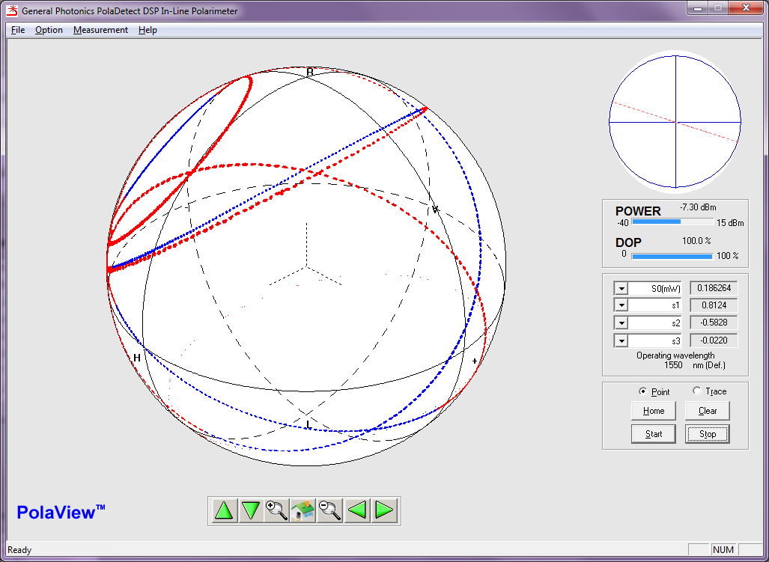 | 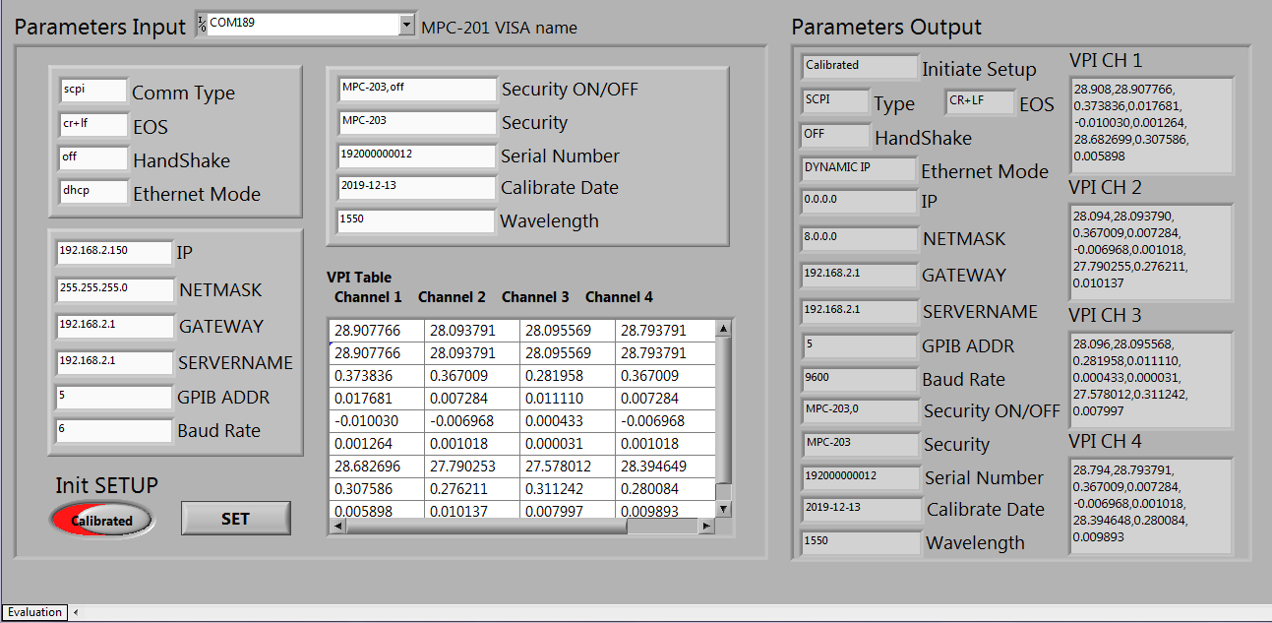

c). Channel 7 V_{2π} calibration

V_{2π} Calibration
Wave Type | Triangle
Frequency | 0.1Hz | 1Hz | 10Hz | 50Hz | 0.1kHz | 0.2KHz | 0.5KHz | 1KHz
V_{2π}(V) | N/A | N/A | N/A | N/A | N/A | N/A | N/A | N/A
CH 7 | Quartic trend line |  |  |  | Quadratic trend line
CH 7 | 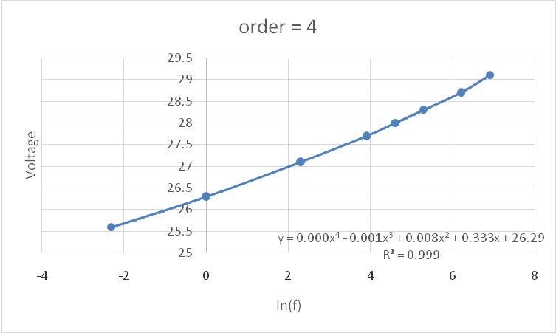 |  |  |  | 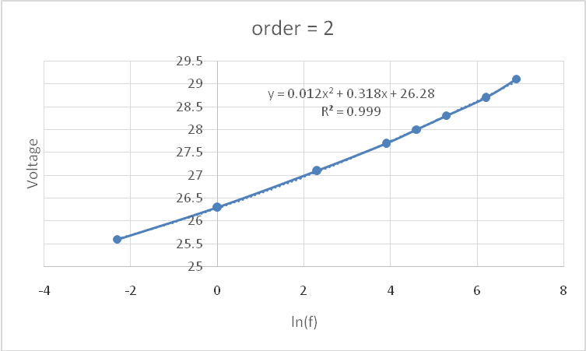

5. Optical Head Temperature Calibration Results:

Operator |  |  |  | Date
T (°C) | 60kHz V_{2π} in Digital  (60~250) | 130kHz V_{2π} in Digital  (200~250) | T (°C) | 60kHz V_{2π} in Digital  (60~250) | 130kHz V_{2π} in Digital  (200~250) | Reference voltage applied
10 | N/A | N/A | 28 | N/A | N/A | V_{ref1} = ____ N/A __ AD  V_{ref2} = ___ N/A ___ AD
12 | N/A | N/A | 30 | N/A | N/A | V_{ref1} = ____ N/A __ AD  V_{ref2} = ___ N/A ___ AD
14 | N/A | N/A | 32 | N/A | N/A | V_{ref1} = ____ N/A __ AD  V_{ref2} = ___ N/A ___ AD
16 | N/A | N/A | 34 | N/A | N/A | V_{ref1} = ____ N/A __ AD  V_{ref2} = ___ N/A ___ AD
18 | N/A | N/A | 36 | N/A | N/A | V_{ref1} = ____ N/A __ AD  V_{ref2} = ___ N/A ___ AD
20 | N/A | N/A | 38 | N/A | N/A | V_{ref1} = ____ N/A __ AD  V_{ref2} = ___ N/A ___ AD
22 | N/A | N/A | 40 | N/A | N/A | V_{ref1} = ____ N/A __ AD  V_{ref2} = ___ N/A ___ AD
24 | N/A | N/A | 42 | N/A | N/A | V_{ref1} = ____ N/A __ AD  V_{ref2} = ___ N/A ___ AD
26 | N/A | N/A |  |  |  | V_{ref1} = ____ N/A __ AD  V_{ref2} = ___ N/A ___ AD

6. Optical Head Scrambling Rate Calibration for Tornado Mode

Operator |  | N/A |  | Date |  | N/A
Scrambling Range (krad/s) | 20 – 11010 krad/s
20~170 | Frequency step size @ 170krad/s _____ N/A ____
190~2610 | V_{ref 1}= ____________@ 2610krad/s
2630~11010 | Scrambling Speed (krad/s) |  | V_{ref 2} (AD) |  | V_{ref2} calculated from trend line (AD)
2630~11010 | 11010 |  | N/A |  | N/A
2630~11010 | 9810 |  | N/A |  | N/A
2630~11010 | 8810 |  | N/A |  | N/A
2630~11010 | 7810 |  | N/A |  | N/A
2630~11010 | 6810 |  | N/A |  | N/A
2630~11010 | 5810 |  | N/A |  | N/A
2630~11010 | 4810 |  | N/A |  | N/A
2630~11010 | 3810 |  | N/A |  | N/A
2630~11010 | 2630 |  | N/A |  | N/A
2630~11010 | Trend line and fitting curve of V_{ref2}:
2630~11010 | 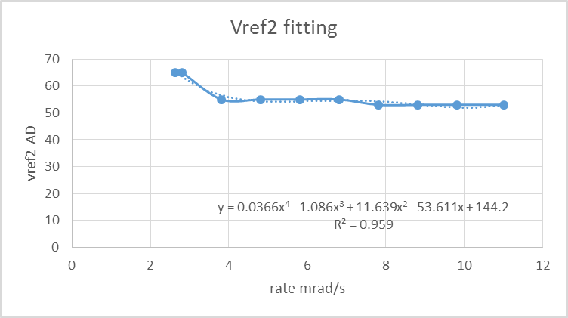

7. Final Test:
Operator | Leo Wang |  | Date |  |  | 06/29/2022
Key Pad, Display, Function and spec | Pass: Fail: |  | Insertion Loss (dB) (<0.6dB) |  |  | 0.53
Trigger In &Out | Pass: Fail: |  | Return Loss(dB)  PC > 50dB; APC > 55dB |  |  | >50
Communication Test | 1. RS-232 | Pass: Fail: |  |  | 3. Ethernet | Pass: Fail:
Communication Test | 2. USB | Pass: Fail: |  |  | 4. GPIB | Pass: Fail:
Tornado mode speed measurement | Setting (krad/s) |  |  | Measured speed (krad/s)
Tornado mode speed measurement | 170 |  |  | 168.98
Tornado mode speed measurement | 2610 |  |  | 2586.92
Tornado mode speed measurement | 11010 |  |  | 10288.070
8. Final Packaging:
Glue all Screws and Connectors. Clean and Visual Check | Operator: Leo Wang | Date: 06/28/2022
Power on checking: 110V 220V | Operator: Leo Wang | Date: 06/29/2022
9. Overnight Burn
110V 220V | Start Time: | Finish Time (>12hrs):
Operator: | Date: 06/29/2022

Pass Fail Supervisor: _____________ Date: _____________

Pass Fail FQC: __________________ Date: _____________

